HANDS ON – Keerthivasan R DAY-30

Problem Statement: Implement Dependency Injection in ASP.NET Core

📌 Background
A growing e-commerce company wants to build a modular and maintainable web application using ASP.NET Core MVC. The development team wants to reduce tight coupling between components and improve testability of the application.
To achieve this, they decide to implement Dependency Injection (DI) using the built-in IoC container of ASP.NET Core.

🎯 Objectivej
Develop a simple Product Management module that demonstrates the implementation of Dependency Injection in ASP.NET Core.

📂 Functional Requirements
The system should:
- Display a list of products.
- Add a new product.
- Retrieve product details by ID.
- Delete a product.

🏗 Technical Requirements

1️⃣ Create an Interface
- Define an interface IProductService with methods:
  - GetAllProducts()
  - GetProductById(int id)
  - AddProduct(Product product)
  - DeleteProduct(int id)

2️⃣ Create a Service Class
- Implement the interface in ProductService.
- Add sample in-memory data (no database required for simplicity).

3️⃣ Register Services
- Register the service in Program.cs using:
  - AddScoped()
  - AddTransient()
  - or AddSingleton()

4️⃣ Inject Dependency
- Inject IProductService into:
  - ProductController via Constructor Injection.

🧠 Key Learning Outcomes
Students should understand:
- What is Dependency Injection?
- Why DI reduces tight coupling.
- Difference between:
  - Transient Lifetime
  - Scoped Lifetime
  - Singleton Lifetime
- Constructor Injection in ASP.NET Core.
- How DI improves unit testing.

⚙ Expected Output
- Application runs successfully.
- Controller accesses service without creating object manually.
- No usage of new ProductService() inside controller.
- Proper separation of concerns followed.

📌 Evaluation Criteria
- Proper interface implementation.
- Correct service registration.
- Clean architecture.
- Code reusability.
- Understanding of DI lifetimes.

CODE:
Model/ Product.cs
namespace ProductManagementSystem.Models
{
public class Product
{
public int Id { get; set; }
public string Name { get; set; }
public double Price { get; set; }
}
}

Service/ IProductService.cs
using ProductManagementSystem.Models;

namespace ProductManagementSystem.Services
{
public interface IProductService
{
IEnumerable<Product> GetAllProducts();

Product GetProductById(int id);

void AddProduct(Product product);

void DeleteProduct(int id);
}
}

Service/ ProductService.cs
using ProductManagementSystem.Models;

namespace ProductManagementSystem.Services
{
public class ProductService : IProductService
{
private static List<Product> _products = new()
{
new Product { Id = 1, Name = "Laptop", Price = 1200 }
};
public IEnumerable<Product> GetAllProducts() => _products;

public Product? GetProductById(int id) => _products.FirstOrDefault(p => p.Id == id);

public void AddProduct(Product product) => _products.Add(product);

public void DeleteProduct(int id) => _products.RemoveAll(p => p.Id == id);
}
}

Controller/ ProductController.cs
using Microsoft.AspNetCore.Mvc;
using ProductManagementSystem.Models;
using ProductManagementSystem.Services;

namespace ProductManagementSystem.Controllers
{
public class ProductController : Controller
{
private readonly IProductService _productService;

public ProductController(IProductService productService)
{
_productService = productService;
}

// 1. Display List
public IActionResult Index()
{
var products = _productService.GetAllProducts();
return View(products);
}

// 3. Retrieve Details by ID
public IActionResult Details(int id)
{
var product = _productService.GetProductById(id);
if (product == null) return NotFound();
return View(product);
}

// 2. Add Product (The Form Page)
public IActionResult Create() => View();

[HttpPost]
public IActionResult Create(Product product)
{
_productService.AddProduct(product);
return RedirectToAction("Index");
}

// 4. Delete Product
public IActionResult Delete(int id)
{
_productService.DeleteProduct(id);
return RedirectToAction("Index");
}

}
}

Program.cs
using ProductManagementSystem.Services; // Add this using

var builder = WebApplication.CreateBuilder(args);

builder.Services.AddScoped<IProductService, ProductService>();

// Add services to the container.
builder.Services.AddControllersWithViews();

var app = builder.Build();

// Configure the HTTP request pipeline.
if (!app.Environment.IsDevelopment())
{
app.UseExceptionHandler("/Home/Error");
// The default HSTS value is 30 days. You may want to change this for production scenarios, see https://aka.ms/aspnetcore-hsts.
app.UseHsts();
}

app.UseHttpsRedirection();
app.UseStaticFiles();

app.UseRouting();

app.UseAuthorization();

app.MapControllerRoute(
name: "default",
pattern: "{controller=Home}/{action=Index}/{id?}");

app.Run();

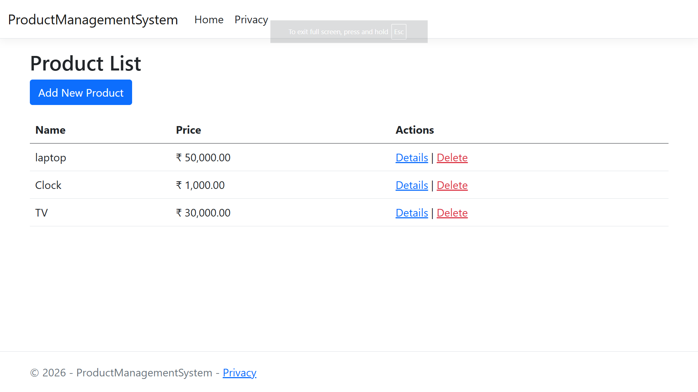
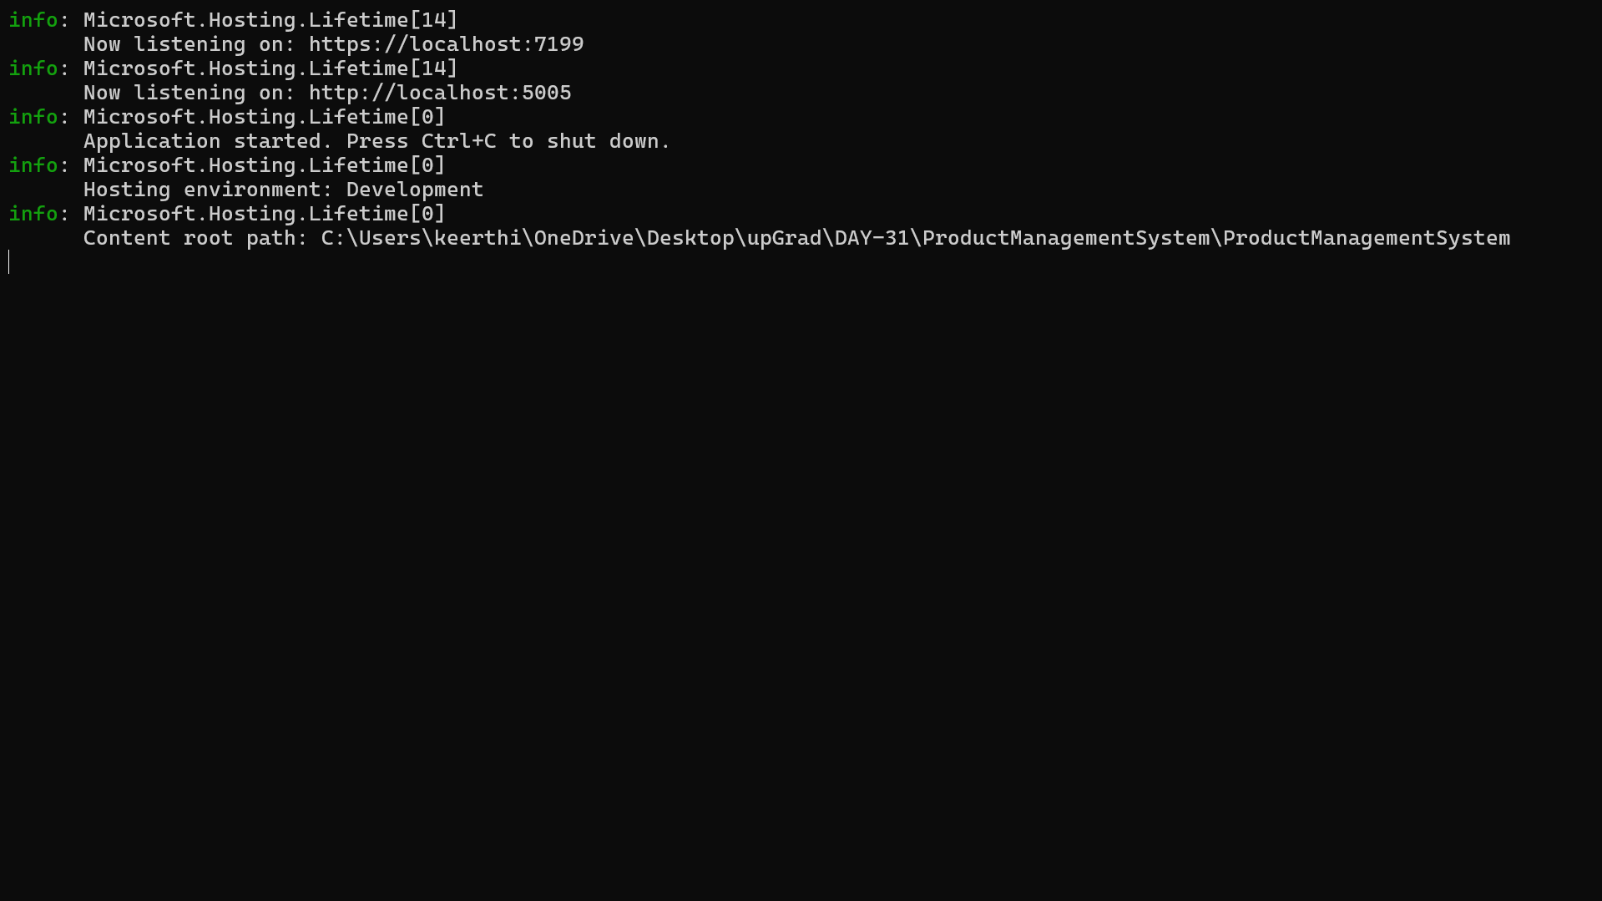
OUTPUT:

